Q1. a. Suppose we have a finite state machine defined by the following graph: (8)

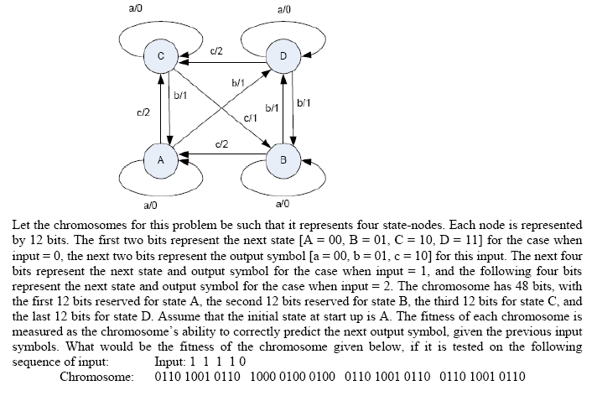

b. Using minimum number of bits, form a bit-string type chromosome comprising of
three genes x, y & z: where (3)

i) x = 3, y = 5, z = 1 (The range of values for each allele is 0-7)
ii) x = windy, y = cloudy, z = hot (There are 2 possible values for each allele)
iii) x = 128, y = 255, z = 32 (The range of values for each allele is 0-255)

Q3. a. Draw architecture of a typical expert system given in the book by George F. Luger. Briefly define the three main types of expert systems? (8)

Q4. a. Mini-max Search (5)

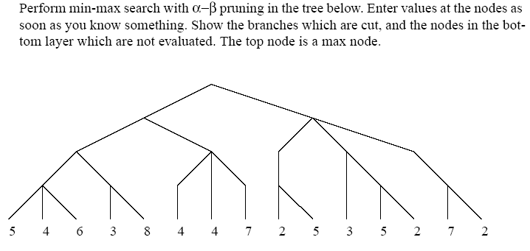

b. Suppose we have the following supervised data

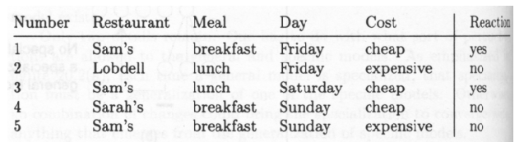

Suppose we have a chromosome: Sam – X – X - X
which represents the rule:
IF Restaurant = Sam, and Meal = X, and Day = X, and Cost = X ,
THEN Reaction = Yes ELSE Reaction = No
(where X is a general, don’t care value which matches every value)
What would be the fitness of the chromosome, if the fitness function is the number of data samples which are correctly classified by the chromosome. (3)

Q5. a. In Genetic Algorithm, a generation has 50 chromosomes, out of which 5 fittest ones are placed in the next generation without any competition from the offspring. The rest of the 45 chromosomes of the next generation are chosen from the pool of parents and offspring. Suppose 30 chromosomes of the offspring make it to the new generation. What is the generation gap and what is the elitism value. Duplicates are not allowed. (4)

Q6. a. Suppose there are 10 chromosomes with fitness as shown in table. What will be there selection probability according to proportionate and linear rank selection method: (5)

Chromosome No. Fitness Proportionate Linear Rank

A 50
B 25
C 25
D 100
E 75
F 125
G 250
H 110
I 140
J 100
Another Linear rank selection method can be to assign a probability ‘m’ to the fittest chromosome, and the probability ‘(1-m)*m’ to the second highest, and the probability ‘(1-m)*(1-m)*m’ to the third highest and so on.

b. If two parents are to be selected by tournament selection and the two randomly selected chromosomes sets are {A, D, H}, and {C, D, J}; which two chromosomes will be selected as parents. The fitness of chromosomes are A = 10, D = 18, H = 12, C = 5, J = 12. (3 marks)

Q7. a. Suppose, there are 9 rules in a fuzzy expert system, out of which 3 rules fire for a certain set of input conditions. The output parameter Y has the following membership values for these 3 rules:

Y’ = 0/100, 0.25/200, 0.5/300, 0.75/400, 1/500, 0.75/600, 0.5/700, 0.25/800,
0/900, 0/1000
Y’ = 0.5/100, 0.75/200, 0.75/300, 0.75/400, 1/500, 0.75/600, 0.5/700, 0.25/800,
0/900, 0/1000
Y’ = 0/100, 0/200, 0/300, 0.75/400, 0.75/500, 0.75/600, 0.5/700, 0/800, 0/900,
0/1000

What will be the unified value of the output? (4)

b. Find the intersection, union and complements of fuzzy sets A & B: (3)

A = {0/10, 0.6/20, 1/30, 1/40, 0.3/50, 0.1/60, 0/70, 0/80, 0.5/90, 1/100}

B = {1/10, 0.5/20, 0/30, 0/40, 0.1/50, 0.3/60, 1/70, 1/80, 0.6/90, 0/100}

c. Implement a “Fuzzy Logic Based Washing Machine” that automatically selects the operating time and saves electrical power wastage. Consider only one control variable: the operating time of the machine for each given load of clothes. The operating time is supposed to depend on two properties: how dirty the clothes are, and what type of dirtiness is present. Define the fuzzy sets, fuzzy rules and build the complete system. (8)

